FOR IMMEDIATE RELEASE
Body Armor announces postponed charity event with the Right to Play Organization.
New York, N.Y. – April 30, 2020 – Body Armor and the Right to Play Organization are saddened to announce, that due to the coronavirus, the major charity event has been indefinitely postponed. It was supposed was to take place at the United Center on Sunday, July 12, 2020. While this is a decision we wish we did not have to do, Body Armor felt it was essential for everyone participated to stay home and stay safe. The company had been looking at possible ways to safely put on the event, but with rise in Covid-19 cases, it has made it impossible. We currently do not have an exact potential date but hope that it can be rescheduled as soon as possible.
Even though we had to cancel the event, we still wanted to make a difference. That is why Body Armor and the Right to Play are thrilled to announce our virtual 24-hour fundraising campaign. It is not only 24 hours because it equals one day, but particularly in honor of Kobe Bryant. All proceeds will go to benefit first responders and healthcare workers. Even though our main focus is on children and sports, we feel that during this unprecedented time the money should go towards these essential workers. We are incredibly grateful for the bravery and courage that each of those individuals have. Additionally, the goal is to raise $240,000.
If we reach our goal, each of our sponsored athletes have pledged to match it. This includes: Mike Trout, James Harden, Megan Rapinoe, Naomi Osaka, Mookie Betts, Diana Taurasi, and several others. James Harden, Mike Trout and Baker Mayfield, three of our athletes, have pledged to give away four tickets to their teams first home game of the 2021-2022 season. This prize also includes a signed jersey an all access pass before the game, and a fully paid trip to the game as well as a stay in a five-star hotel. This virtual fundraiser will be hosted by a different athlete each hour. Viewers will be able to ask athletes questions through our twitter page and get a live answer right then and there. We have in addition, planned a sports tournament. We will have athletes compete head to head in various competition such as horse, goal scoring competition, and different football drills. The loser will donate $10,000 to a charity of the winners choosing that impacts our vital workers.
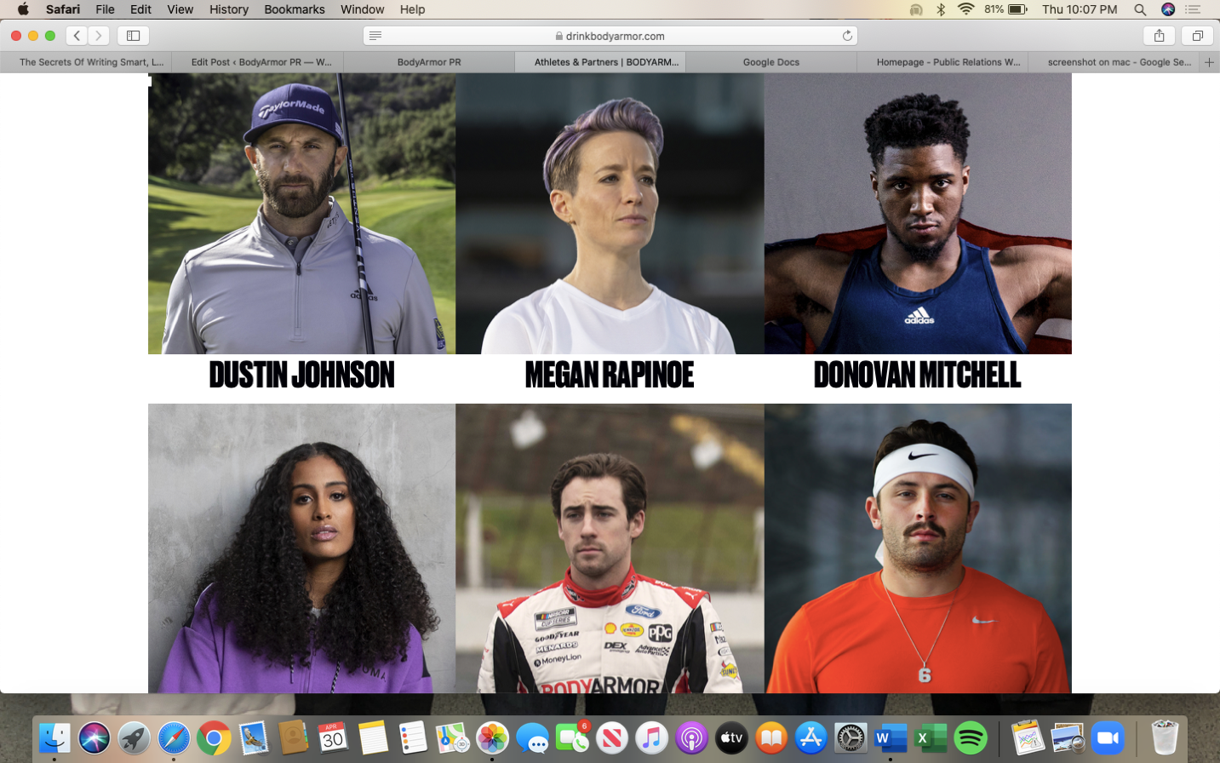
We also plan on having several performances by Ciara, Carrie Underwood, Migos, Alicia Keys and The Rolling Stones. Each performer will perform songs chosen by the audience through our Twitter page and will also be available to answer fan questions. These artists will compete in a jeopardy, trivia game against each other. Questions will be asked by our very own Founder and CEO, Mike Repole. The winner will be able to pick one song from each artist They will provide two lucky fans on an expense paid trip to Los Angeles to attend the Grammy Awards. Our performers have collectively donated $2 million to this fundraiser because they believe in our cause and want to aid in this global pandemic.

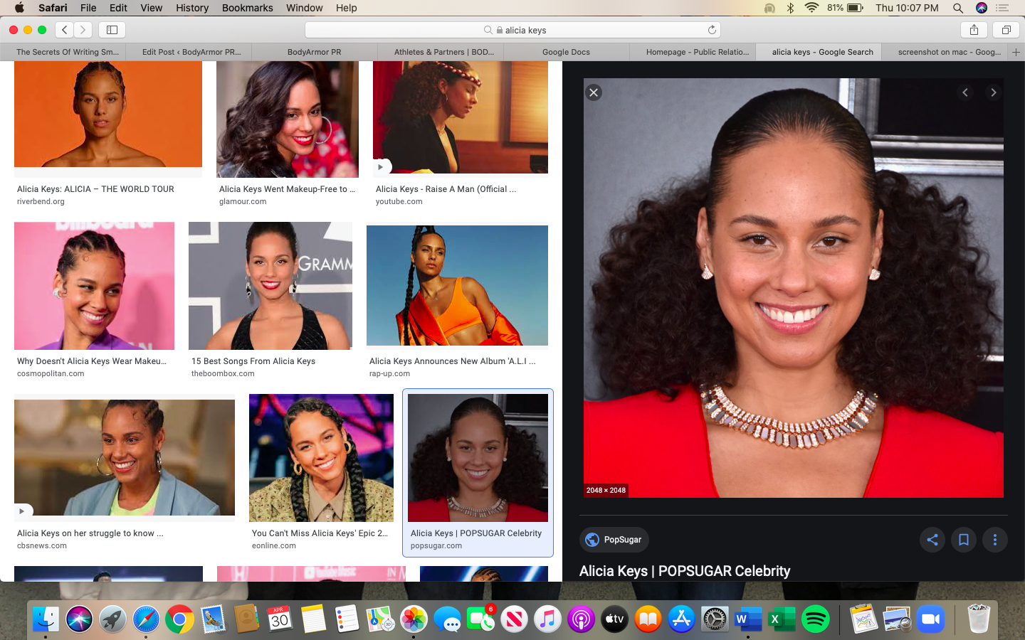
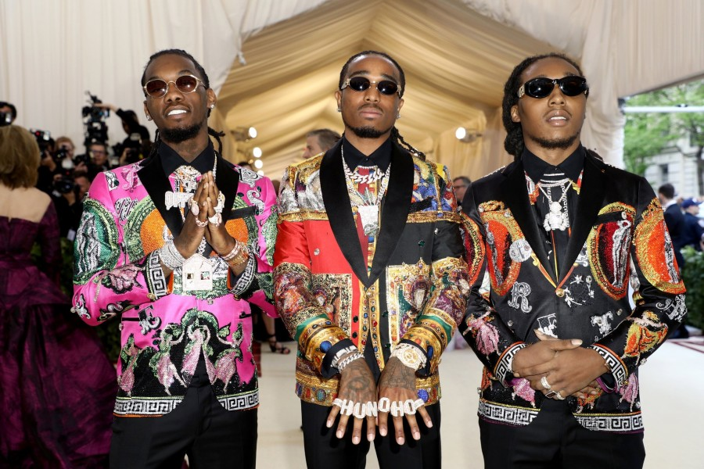

“This virtual extravaganza is something that connects people across the United States. No matter race, gender, religion, sexual orientation, etc., it brings everyone together during this difficult time. I believe in the power of coming together and giving back to those everyday heroes, the ones who risks their lives every single day so people can stay healthy and safe” says Benji Ehigie, PR Manager for Body Armor. More importantly than raising money, we want to give people hope. We hope that through this virtual experience we will be able to show people the “light at the end of the tunnel.”
We will post photos and videos of the event on all of our social media platforms so don’t forget to follow us!

