FOR IMMEDIATE RELEASE
Body Armor announces charity event to raise money for the Right to Play organization.
New York, N.Y. – February 27, 2020 – Body Armor is hosting a major charity event at the United Center located on 1901 W. Madison St, Chicago, Sunday, July 12, 2020. Body Armor is proud to host this event with our new partners The Right to Play Organization. The company has been looking to form a permanent partnership with a non-profit organization that fits its values and missions. The goal is to provide kids from impoverished areas the opportunity to participate in sports, become well-nourished, and gain new life skills.
The event will include games, food, and a live performance and will begin at 9 a.m. and conclude at 7 p.m. Different sports tournaments will be held concurrently for the duration of the occasion. All participants will have the choice of Body Armor to rehydrate during the games. The winner/s will get a year supply of Body Armor and a $500 cash prize per winner.
The event will also have meet and greets with professional athletes that are partnered with Body Armor. This includes: Mike Trout, James Harden, Megan Rapinoe, Naomi Osaka, Mookie Betts, Diana Taurasi, and several others. The athletes will volunteer during the event, followed by autograph signings.
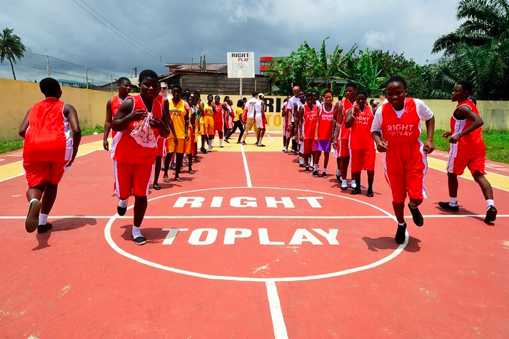
“Sports is something that connects people of all backgrounds. No matter race, gender, religion, sexual orientation, etc., it brings individuals together. I believe in the power of sports and the impact it can have on an individual’s life,” says Benji Ehigie, PR Manager for Body Armor.
We will post photos and videos of the event on all of our social media platforms so don’t forget to follow us!

